PERTH MODERN SCHOOL


UNIT 3C/3D MAS – 2012

TEST 1 – POLAR COORDINATES & COMPLEX NUMBERS

NAME: _________________________________________ DATE: _______________

[To achieve full marks, working and reasoning should be shown.]
[A maximum of 2 marks will be deducted for incorrect rounding, units, notation, etc.]

This is Resource Free – 40 minutes for 36 marks:

- [2, 2, 2 = 6 marks]
Determine 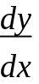 for each of the following

a) y = (e^{2x} + 1)³

b) y = 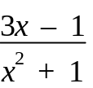

c) y = ln[x²(x + 1)]
2. [4 marks]
Express (1, -1) and (1, 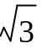) into exact polar form for -π < θ ≤ π.

3. [2 marks]
Find the exact distance between the points A [6, 25⁰] and B [10, 145⁰].

- [3 marks]
Find the polar equation and the Cartesian equation of a circle of centre (0,0) and radius 3.

5. [1, 2, 2 = 5 marks]
Given z = 3 – 3i, calculate:

- z ²

- 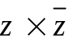

6. 6. [1, 1, 1 = 3 marks]
For each of the following, express p in terms of q.
a) q⁴ = 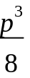

b) log_{e} p = 2 log_{e} q

c) 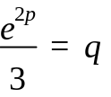

- [3 marks]
The Cartesian equation of a circle is x² + y² = 10. Find the polar equation of this circle.

8. [1, 4, 2 = 7 marks]
If z = cis and w = cis ,
a) express 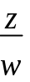 in polar form,

b) express z, w and in Cartesian form, and

c) give with a rationalised denominator.

9. [3 marks]
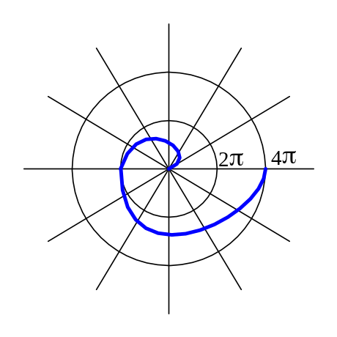Find the polar equation of this curve.

